Hypertext Transfer Protocol
HTTP – application layer protocol used for the World Wide Web, used by Web browsers and servers to communicate.
When a web address or uniform resource locator (URL) is typed into a web browser, the web browser establishes a connection to the web service running on the server using the HTTP protocol.
For better understanding how the web browser and web server interact, we can examine how a web page is opened in a browser. For this example, let’s use the http://www.cisco.com/index.html URL.
First, as shown in Picture 1, the browser interprets the three parts of the URL:
1. Http (the protocol or scheme)
2. www.cisco.com (the server name)
3. Index.html (the specific filename requested)
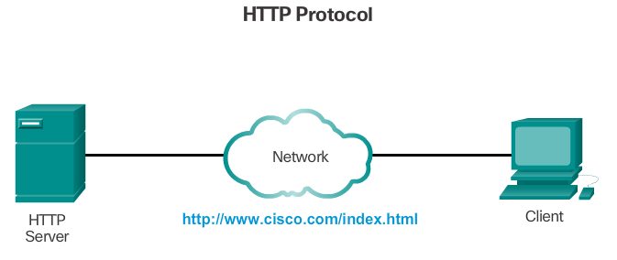
As shown in Picture 2, the browser then checks with a name server to convert www.cisco.com into a numeric address, which it uses to connect to the server. Using HTTP requirements, the browser sends a GET request to the server and asks for the index.html file.
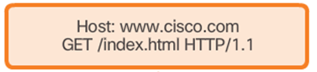
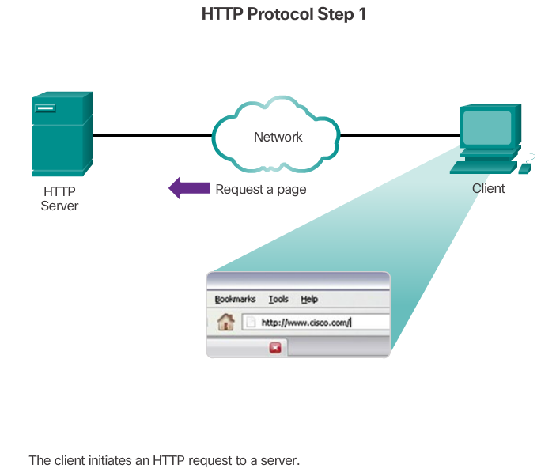
The server, as shown in Picture 3, sends the HTML (Hyper Text Markup language - programming language) code for this web page to the browser.
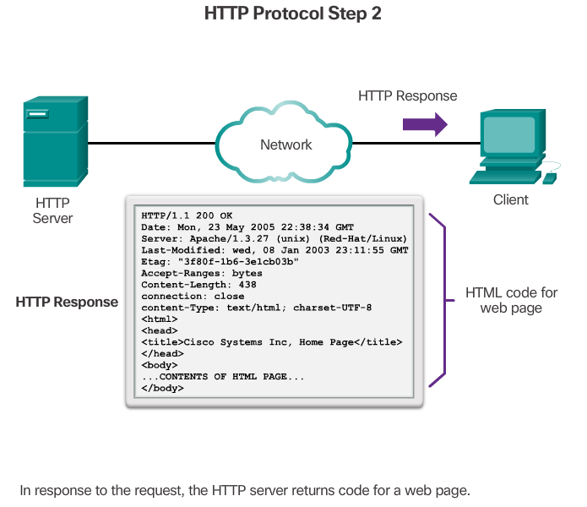
Finally, as shown in Figure 4, the browser deciphers the HTML code and formats the page for the browser window.
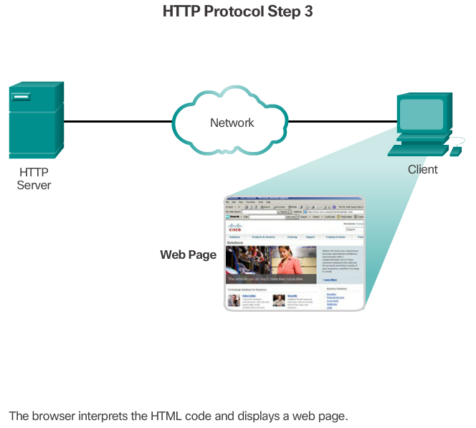

HTTP and HTTPS
HTTP is a request/response protocol. When a client, typically a web browser, sends a request to a web server, HTTP specifies the message types used for that communication. The three common message types are GET, POST, and PUT (see the figure):
- GET - A client request for data. A client (web browser) sends the GET message to the web server to request HTML pages.
GET requests, ask for data and does not modify the data on the server
- POST - Uploads data files to the web server such as form data.
POST changes state on the server after the post, the server has more information than it did before. POST are usually initiated by a web form
- PUT - Uploads resources or content to the web server such as an image.
Although HTTP is remarkably flexible, it is not a secure protocol. The request messages send information to the server in plain text that can be intercepted and read. The server responses, typically HTML pages, are also unencrypted.
For secure communication across the Internet, the HTTP Secure (HTTPS) protocol is used. HTTPS uses authentication and encryption to secure data as it travels between the client and server. HTTPS uses the same client request-server response process as HTTP, but the data stream is encrypted with Secure Socket Layer (SSL) before being transported across the network.
HTTPS – commonly known as SSL – Secure Socket Layer, the S in HTTP stands for secure

VOCABULARY

Encrypted - kódovaný
Unencrypted – nekódovaný
Encryption – zakódování
Intercepted – zachycený
Browser – prohlížeč
Convert – přeměnit
Decipher – rozluštit
Initiated - zahájený
Uploads – vložit (počítačový soubor)

PRACTICE

1. Answer the questions:
- What is HTTP? What is it used by? What is HTTP used for?
- What are three common message types? Describe them.

2. Explain the abbreviations:

HTTP –
SSL –
VRL –
HTTPS –
HTML –

3. Match to the correct definition.
1. GET a) Uploads resources or content to the web server such as an image.
2 .POST b) Uploads data files to the web server such as form data.
3. PUT c) A client requests for data

4. Complete the text. There two extra words!

Server communication, network, encryption, protocol, request, client

For secure across the Internet, the HTTP Secure (HTTPS) is used. HTTPS uses authentication and to secure data as it travels between the client and HTTPS uses the same client request-server response process as HTTP, but the data stream is encrypted with Secure Socket Layer (SSL) before being transported across the .

